### **Steps:**

### **Set Up Your Terraform Environment**

* **Install Terraform**: If you haven’t already installed Terraform, download it from Terraform's official site and follow the installation steps.
* **Configure AWS CLI**: Make sure the AWS CLI is installed and configured with the necessary permissions.

### **Create a Terraform Project**

* Create a directory for your project and navigate to it

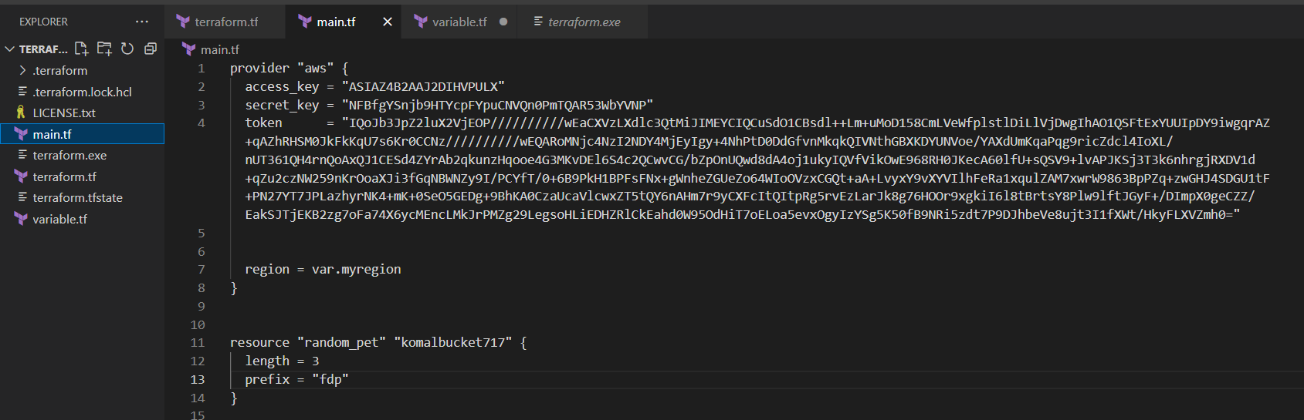

### **Define the Provider**

* In main.tf, start by defining the provider (AWS)

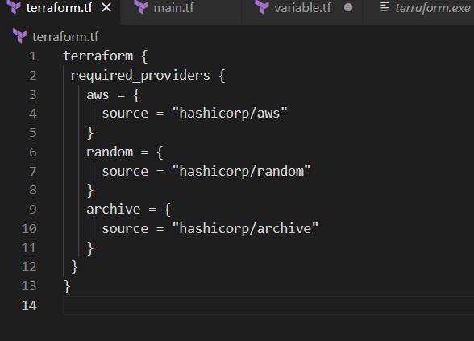

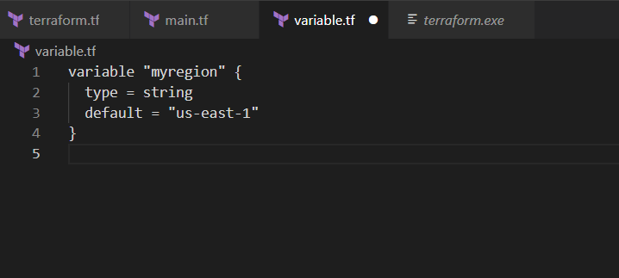

### **Create an S3 Bucket**

* Next, define an S3 bucket where Lambda can receive file uploads.

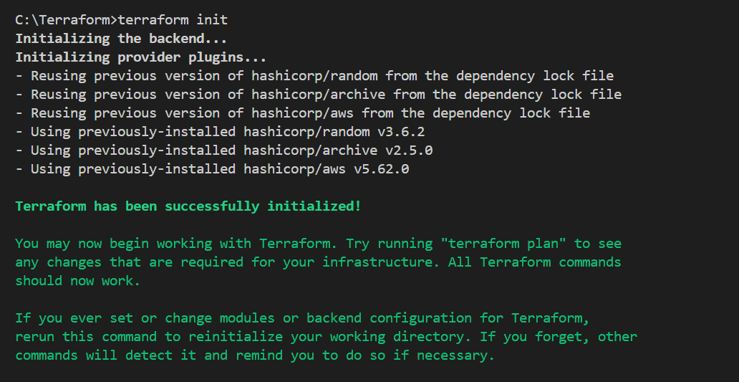

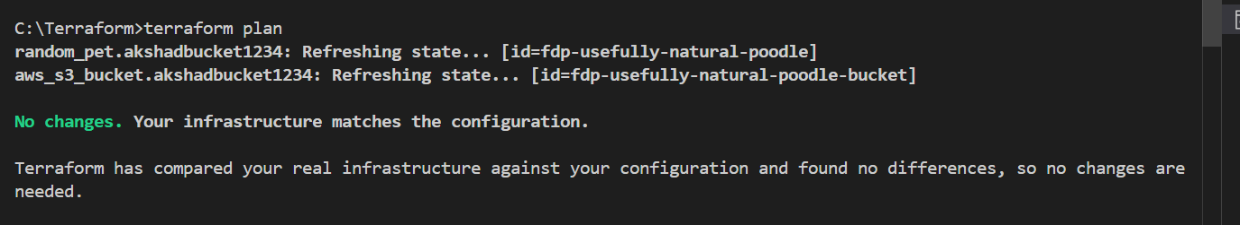

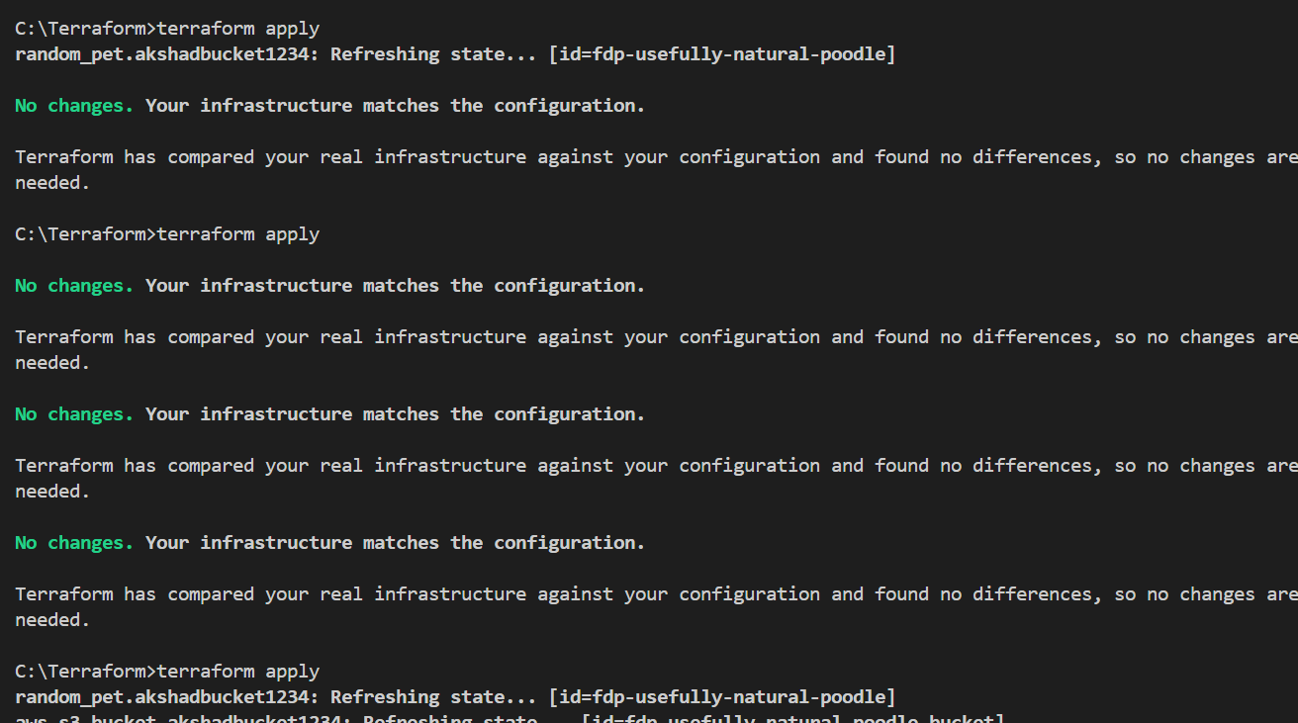

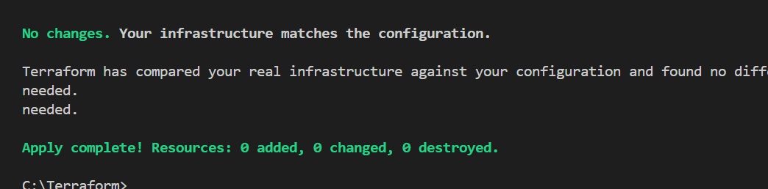

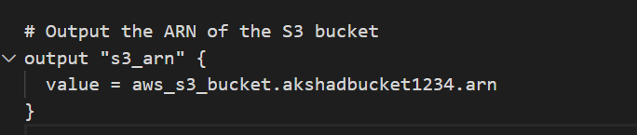

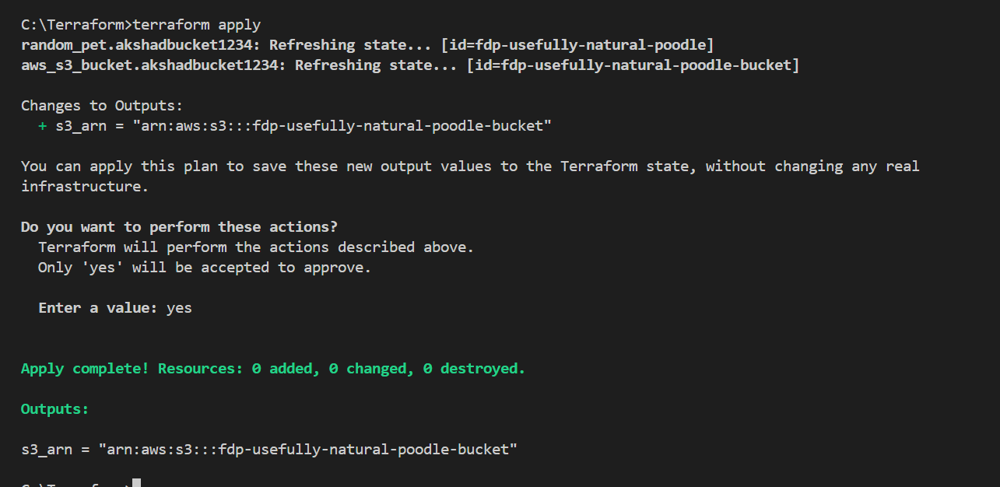

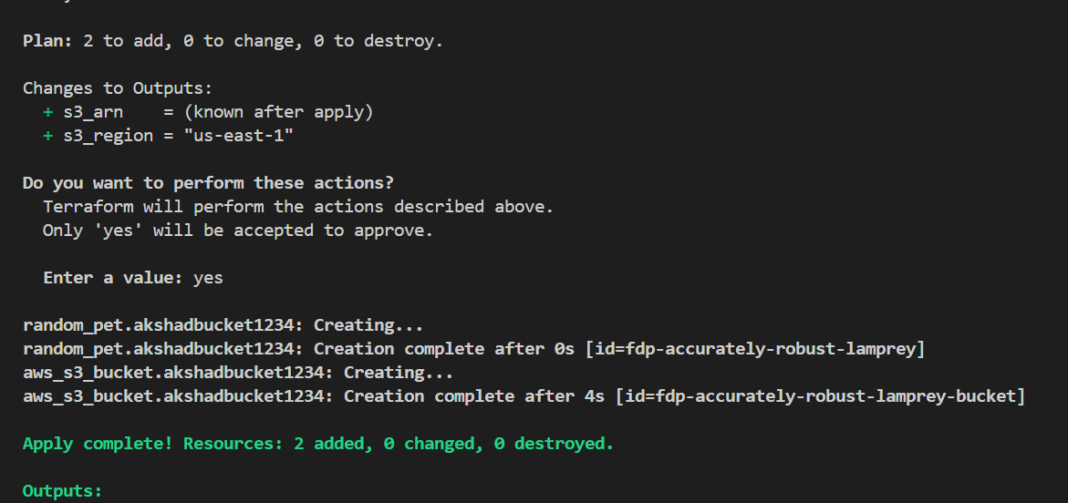

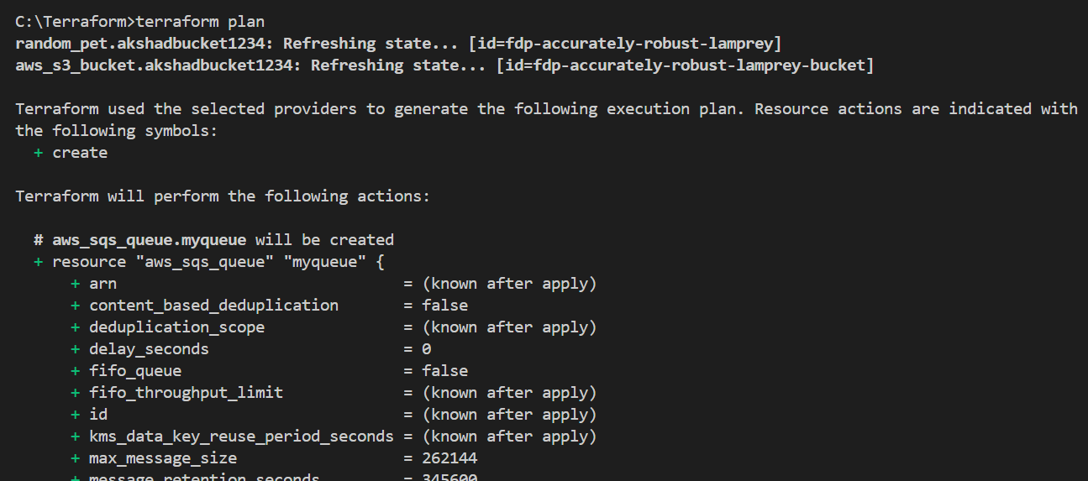

### **Create an SQS Queue**

* Add an SQS queue that will receive events from the S3 bucket when a new object is uploaded.

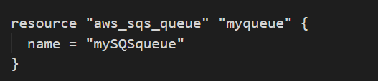

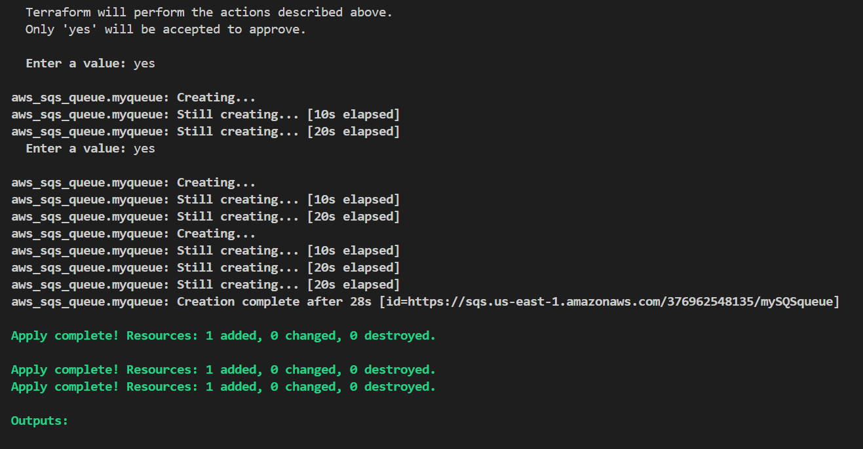

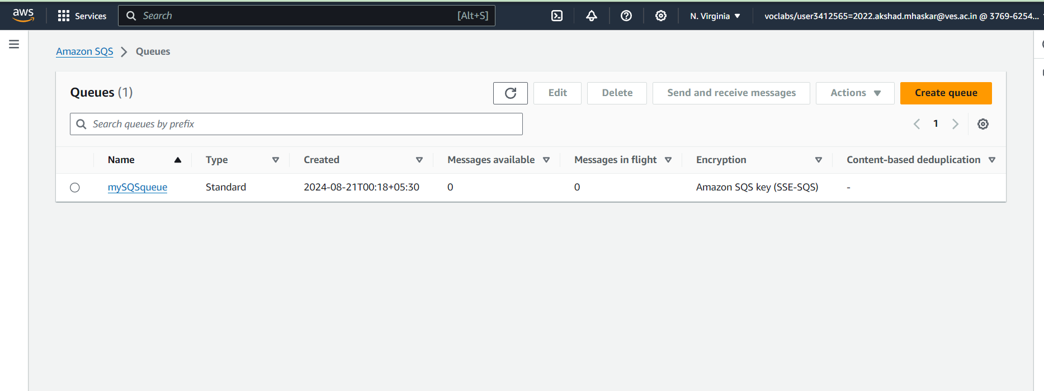

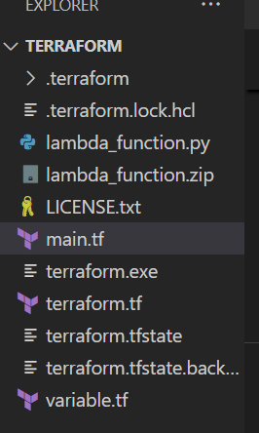

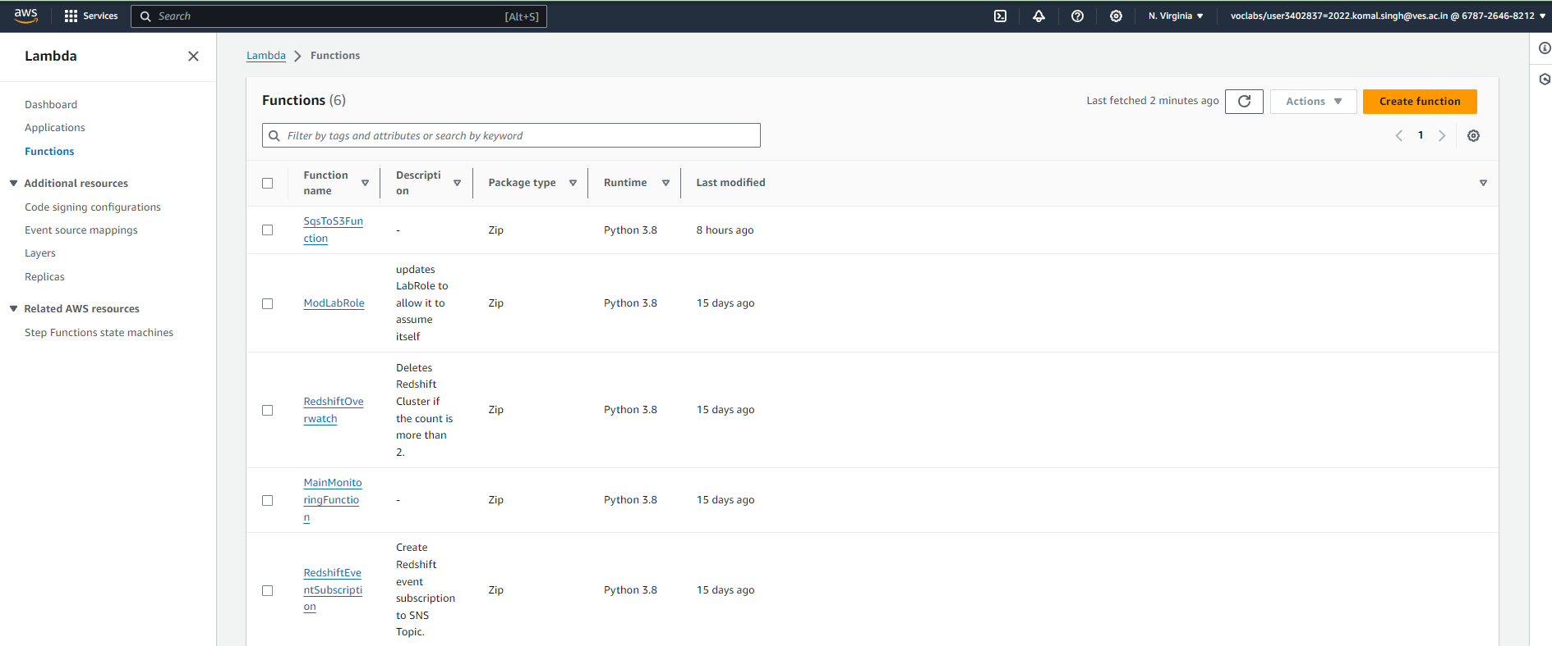

### **Create a Lambda Function**

* Define the Lambda function that will be triggered by S3 events and send messages to SQS. You need a ZIP file containing your Lambda function code, which you can upload to the S3 bucket.

### **Create IAM Role for Lambda**

* Lambda needs permissions to read from S3 and send messages to SQS. Define an IAM role and policy for the Lambda function.

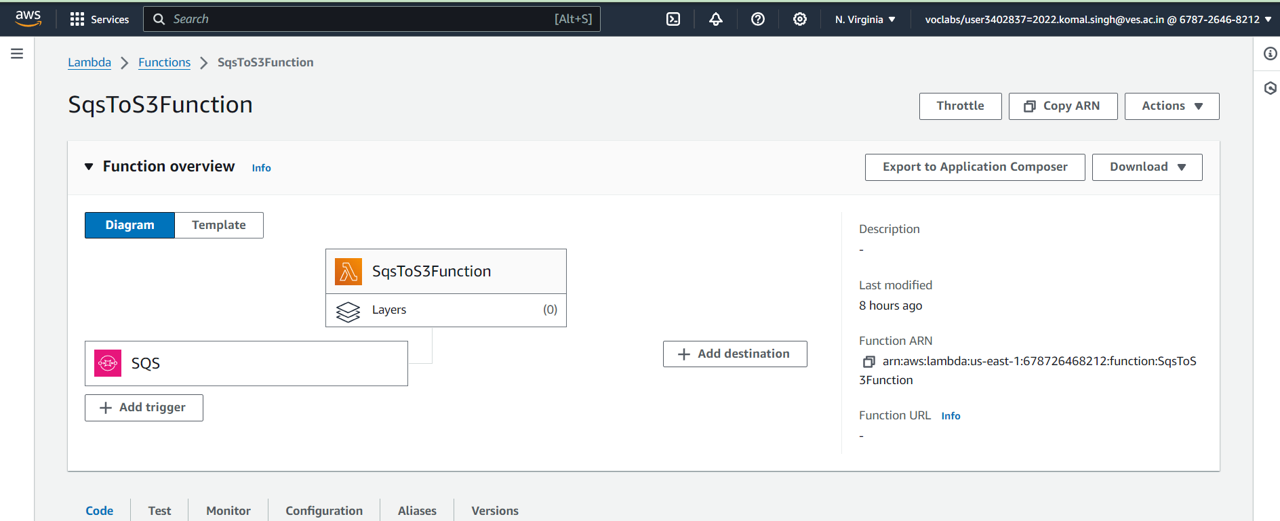

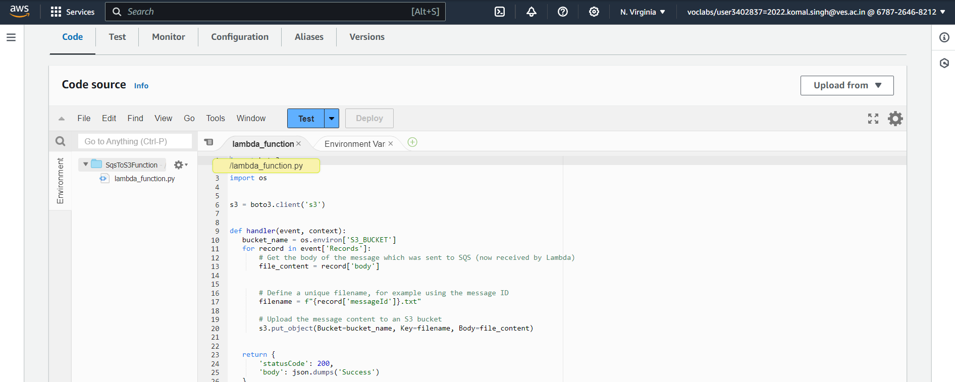

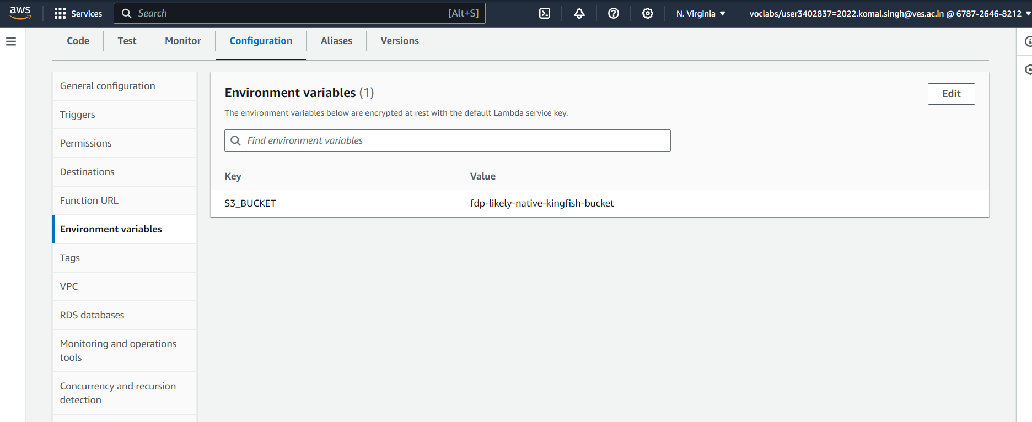

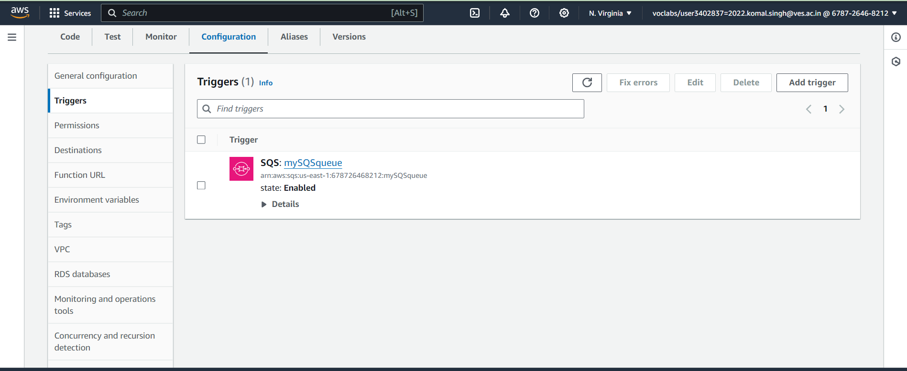

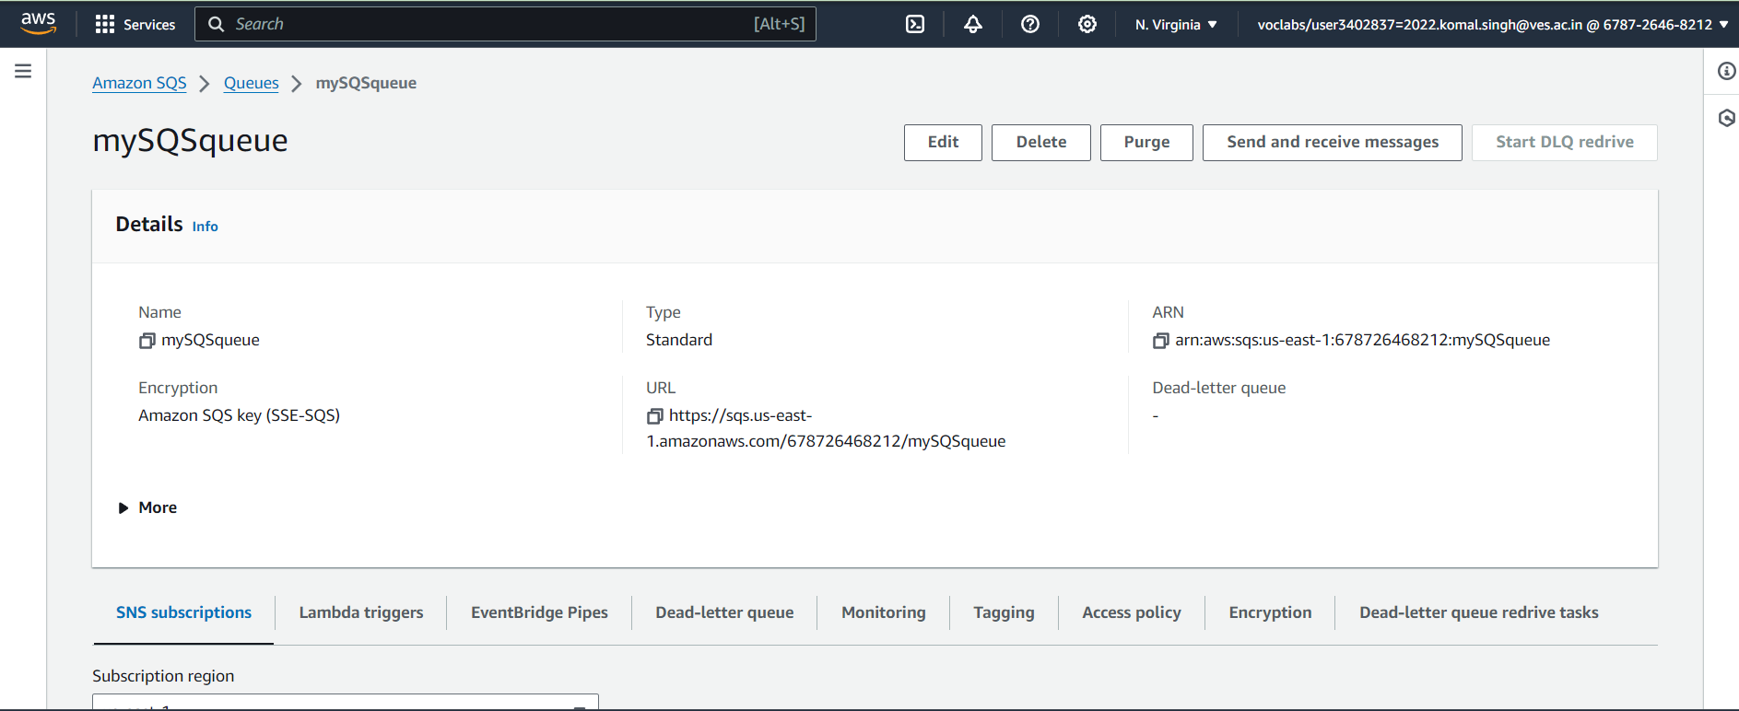

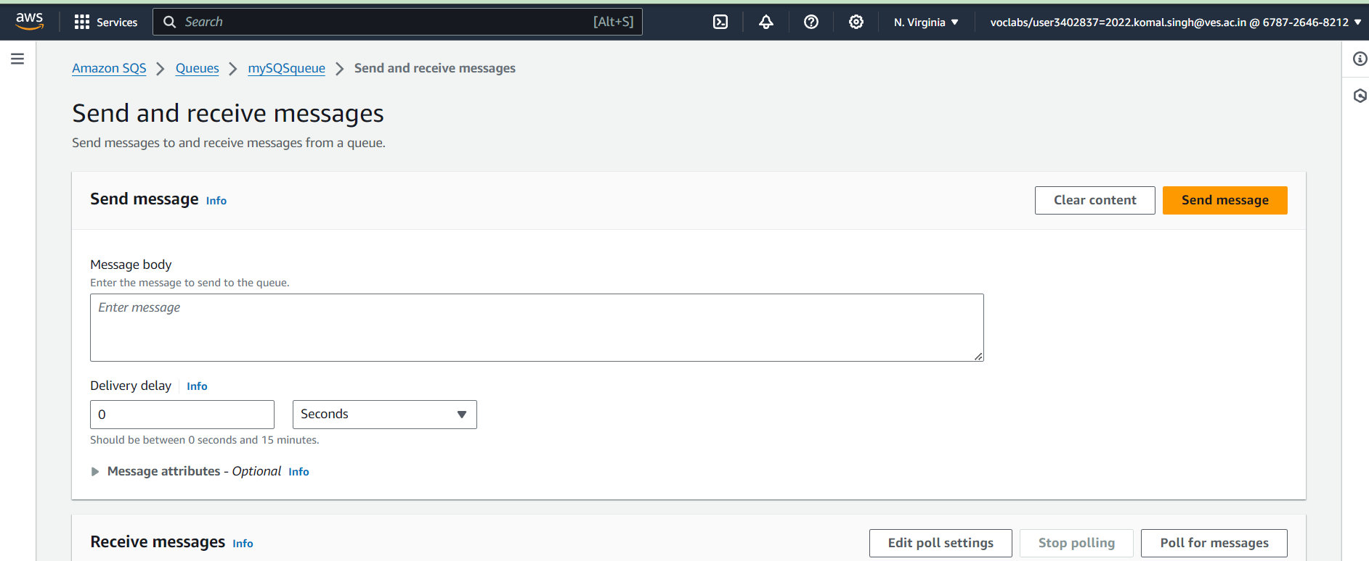

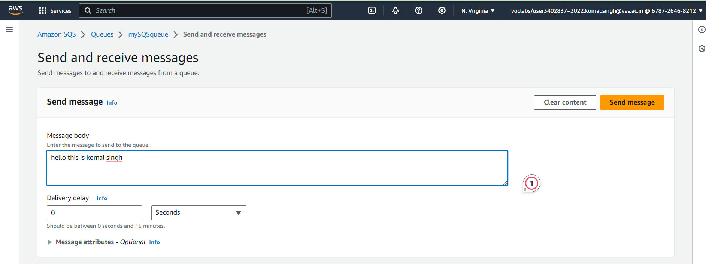

### **Add S3 Event Notification for Lambda Trigger**

* Define a bucket notification to trigger the Lambda function when objects are uploaded to the S3 bucket.

